PIPELINE PROJECT (CI/CD)

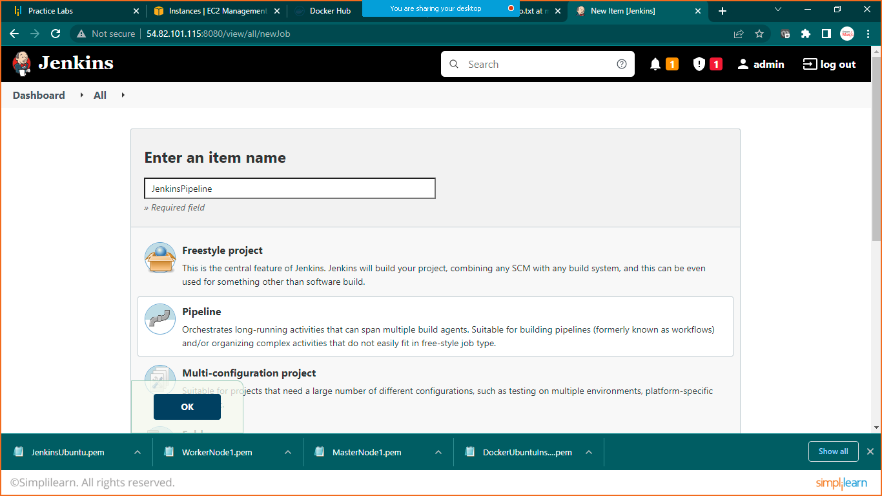

Select pipeline project

Link: https://github.com/Nikunj-Java/SpringBootDockerApp.git

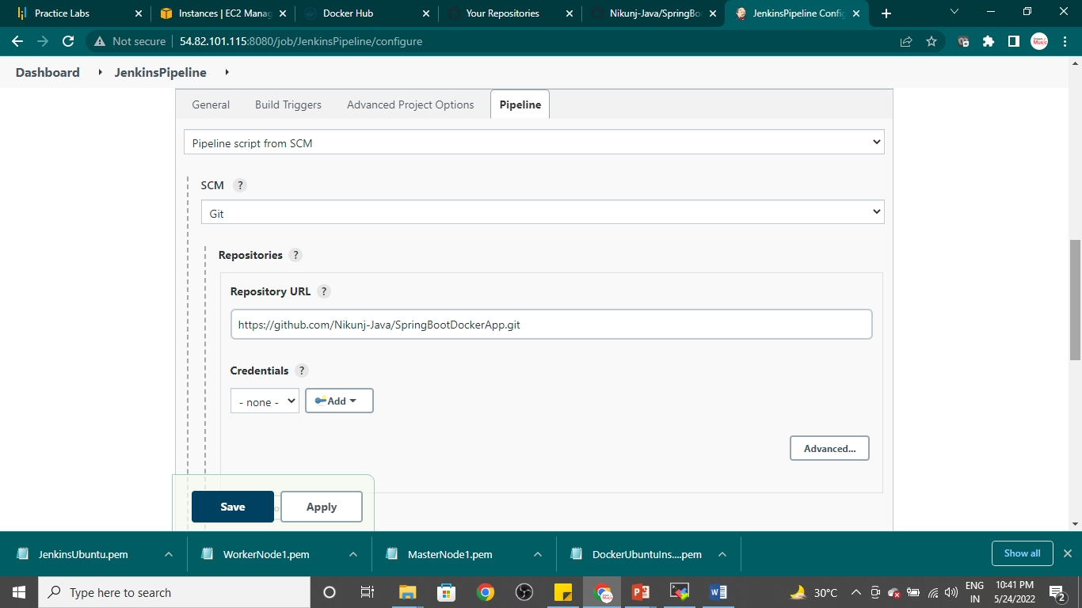

Save it click on build now

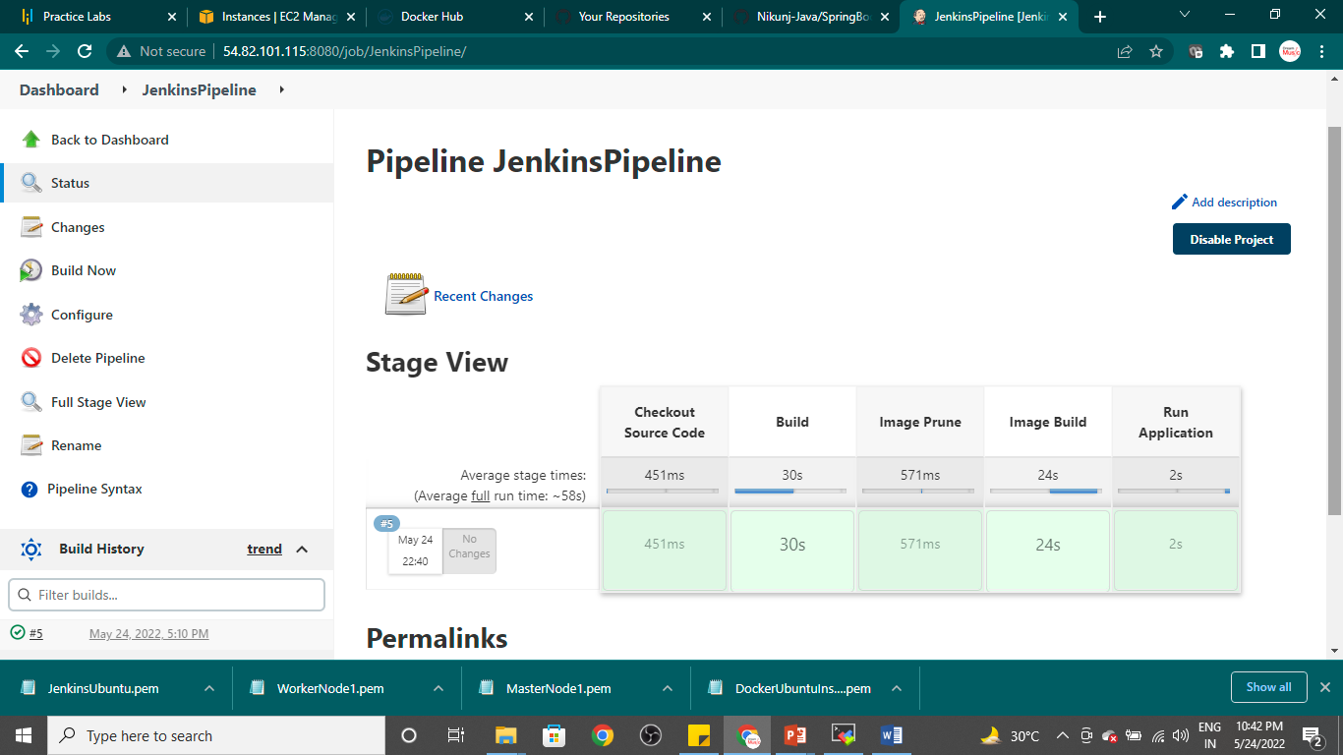

Goto moba xterm and run below code

Sudo docker images